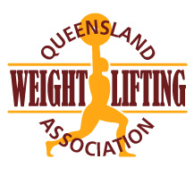
QWA Members with a current Internation Level Referee qualification are invited to nominate for a position as a
QWA Appointed Technical Official
for the following event:

The Event: | 2021 National Masters Championships
Event Date: | 10-12 September 2021
Place: | Cairns, NQ
Closing date for applications: | Monday 23rd August 2021
Type in the shaded fields. Use Tab key to move to the next field.
First Name: Surname:
Address: City: Post code:
Telephone: Email:
- QWA membership must be current Y/N
- Referee qualification (International Cat 1, Cat 2)

- QWA online referee training must have been completed in the past 2 years

(Log into your QWA online account if you need to update your referee training)

- I am able to officiate at all sessions on both days of the event Y/N

- Knowledge of the AWF Member Protection Policy https://www.awf.com.au/corporate/policies

Officiating experience in the past 2 years:
Event | Date | Roles
Example:  QWA State Seniors | 4-5 May 2019 | Announcer, Referee, TC, Timekeeper

Please note that these positions are only available for International level TO’s who are not acting in any other capacity at the event (lifter, coach) and must be available for all sessions of the event.

Send completed applications to:

Email: qwa@qwa.org

