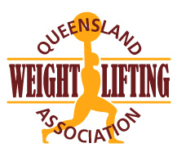
QWA Members are invited to nominate as Team Manager for the following event:

The Event: | 2022 National Junior & U23 Championships
Event Date: | Saturday 26-28 august 2022
Place: | Perth, WA
Closing date for applications: | Thursday 14th July
Type in the shaded fields. Use Tab key to move to the next field.
First Name: Surname:
Address: City: Post code:
Telephone: Email:
- QWA membership must be current Y/N

- Blue Card number must be current: Number Expiry date:

- QWA online referee training must have been completed in the past 12 months

(Log into your QWA online account if you need to update your referee training)

- Sound knowledge of the AWF Member Protection Policy https://www.awf.com.au/corporate/policies

- Sound knowledge of the QWA Team Selection Policy

http://www.qwa.org/Resources/docs/QWA%20Selection%20Policy.pdf

Effective management of representative teams contributes significantly to their overall performance. Team Managers are required to work in close cooperation with the QWA administration, Team Coaches and athletes, to ensure a successful competition for the Team as a whole.

Applicants who have previous experience as a Weightlifting Team Manager or Weightlifting Team Coach will have an advantage.

Please explain how you meet each of the following selection criteria.

1. Demonstrated ability to work within a team environment in both leading and supporting roles

2. Sound knowledge of weightlifting competition regulations and protocols

3. Sound knowledge of sport anti-doping regulations and procedures

4. Possess a high level of communication skills

Send completed applications to:

Email: qwa@qwa.org

